**SUMYAK JAIN, 500068360, R171218106**

**EXPERIMENT-8**

**8.1 Start containers using Kubectl**

1. **Launch Cluster**

minikube start --wait=false

kubectl get nodes

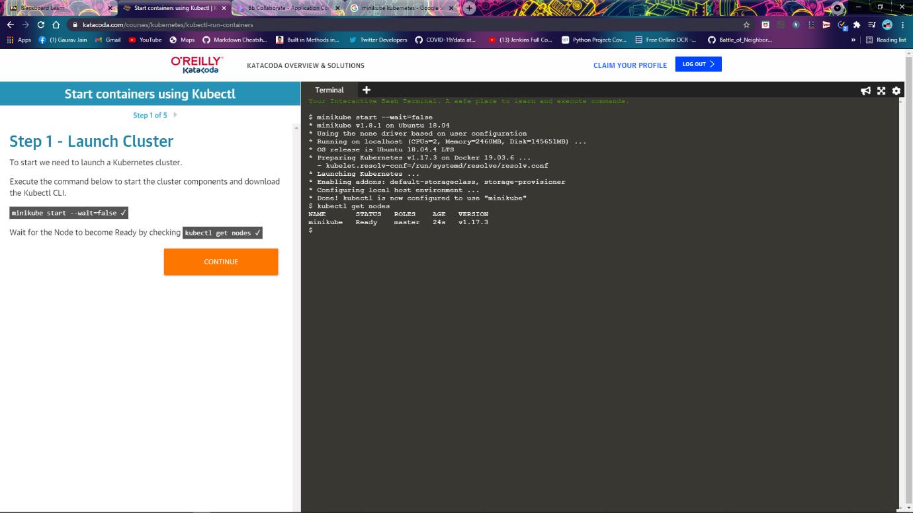

1. **Kubectl run**

kubectl run http --image=katacoda/docker-http-server:latest --replicas=1

kubectl get deployments

kubectl describe deployment http

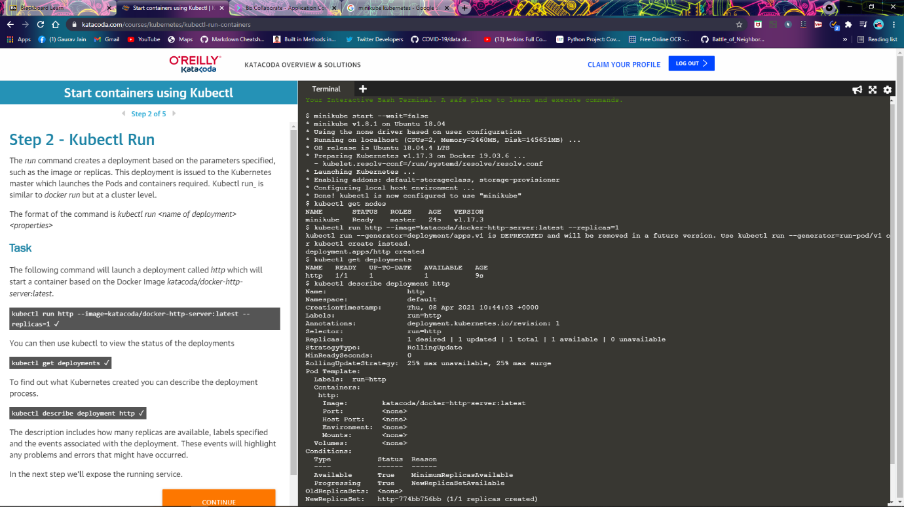

1. **Kubectl Expose**

kubectl expose deployment http --external-ip="172.17.0.40" --port=8000 --target-port=80

curl <http://172.17.0.40:8000>

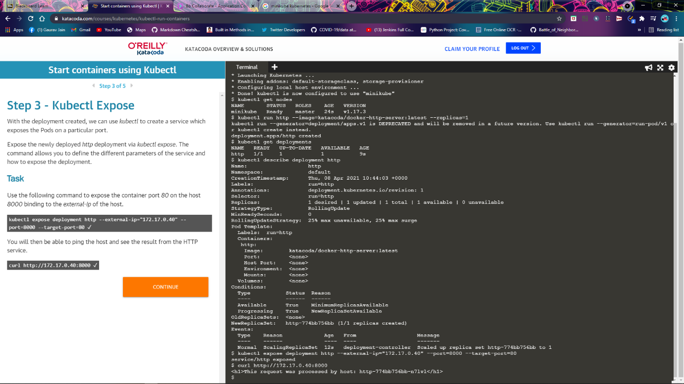

1. **Kubectl Expose**

kubectl run httpexposed --image=katacoda/docker-http-server:latest --replicas=1 --port=80 --hostport=8001

curl http://172.17.0.40:8001

docker ps | grep httpexposed

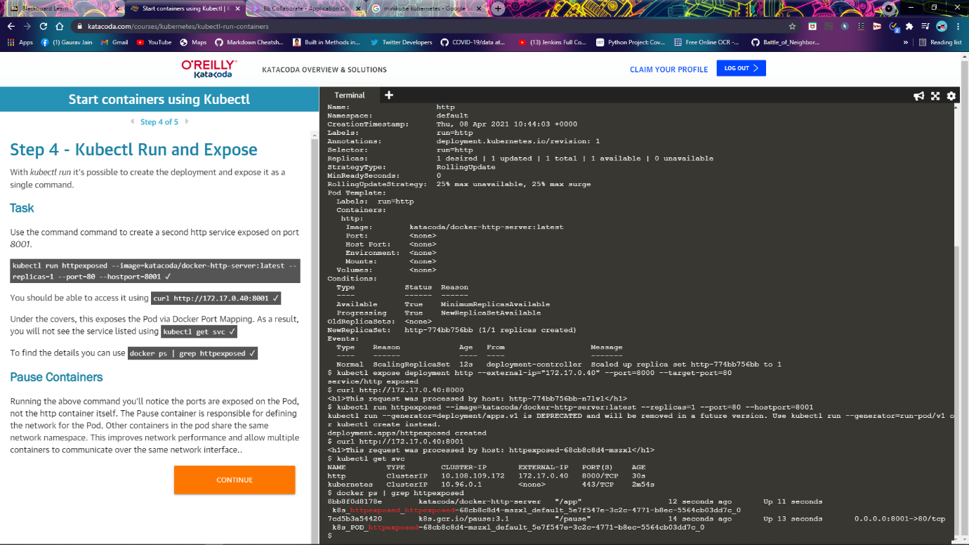

1. **Scale Containers**

kubectl scale --replicas=3 deployment http

 kubectl get pods

curl http://172.17.0.40:8000

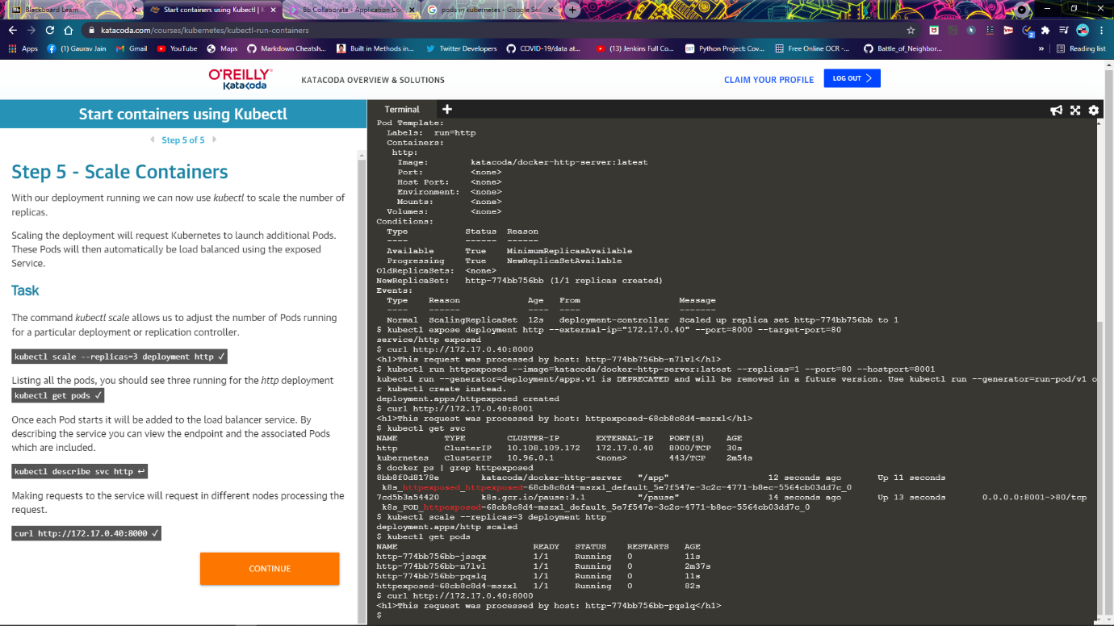

* 1. **Launch Single Node Kubernetes Cluster**

1. **Start Minikube**

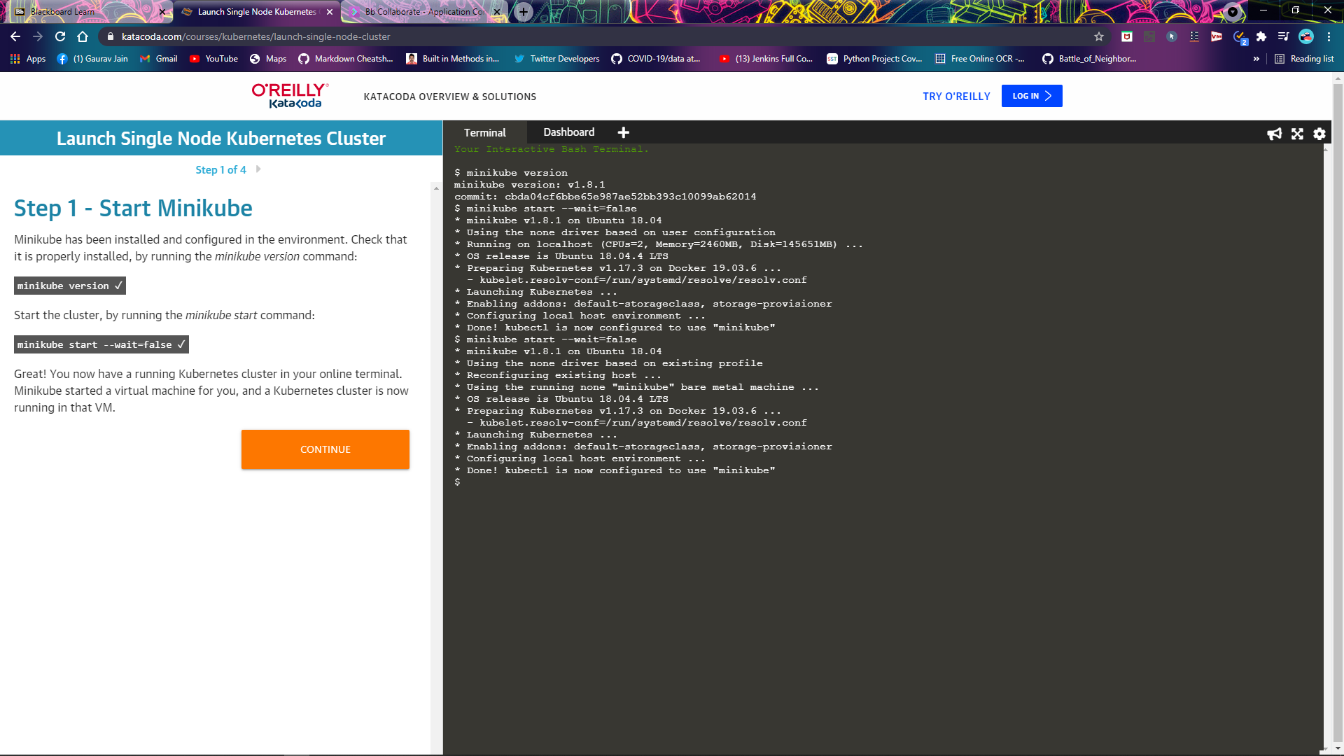

1. **Cluster info**

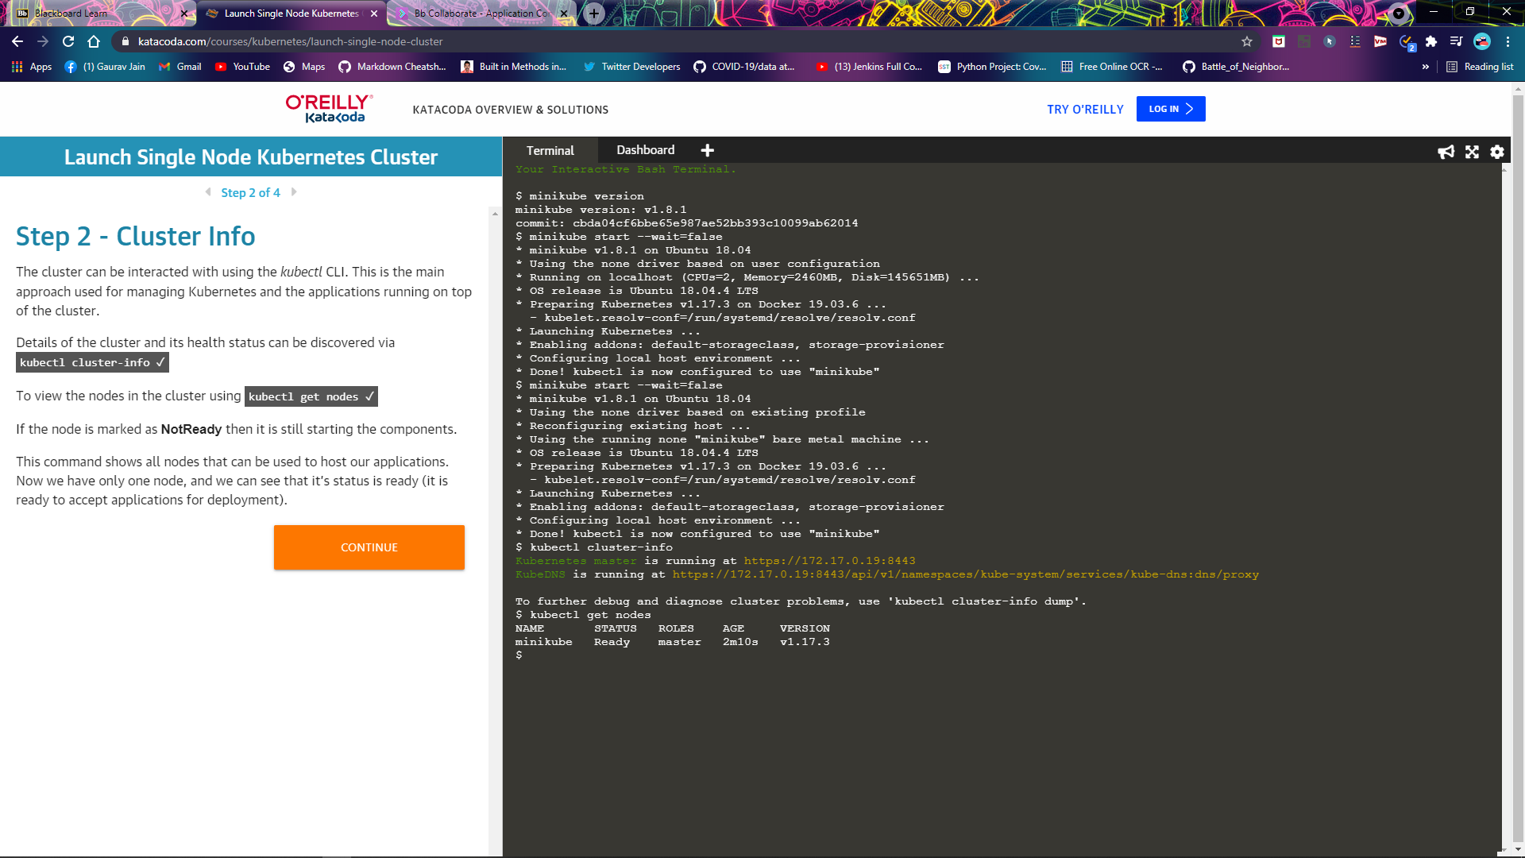

1. **Deploy Containers**

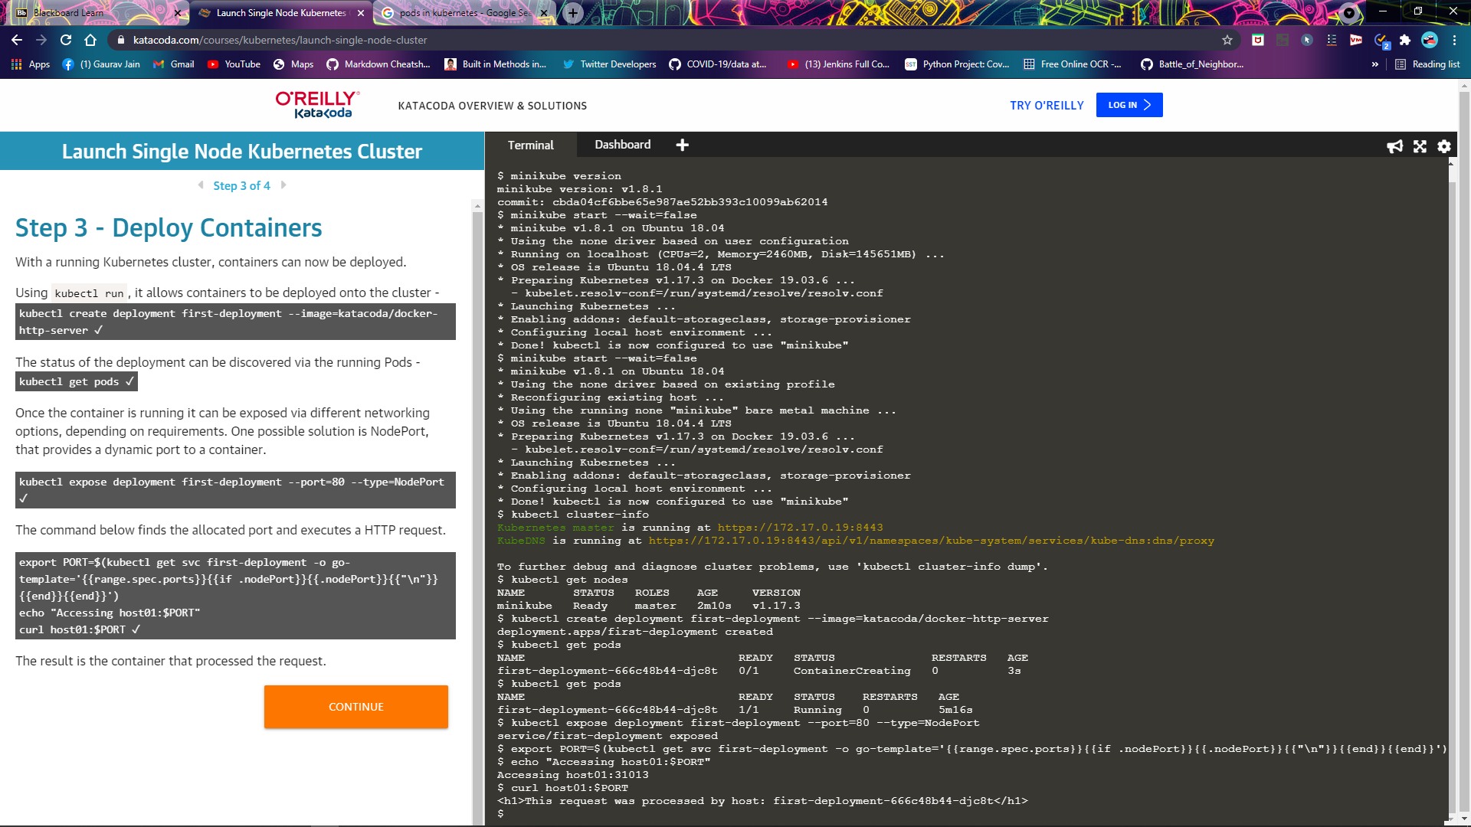

1. **Dashboard**

